How to Install & Setup JMeter on Desktop

1. Install JMeter
   1. Download and unzip JMeter V3.2
   2. Installation is complete and JMeter is ready for usage

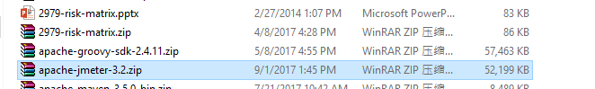

1. In JMeter root directory, the following directories are important
   1. “*\apache-jmeter-3.2\bin*”
      1. Run “jmeter.bat” to start JMeter in windows system
      2. Run “jmeter.sh” to start JMeter in UNIX based systems
      3. “jmeter.log” is the main log file generated by JMeter. All the operations/errors/warnings of the testing will be recorded in this log file

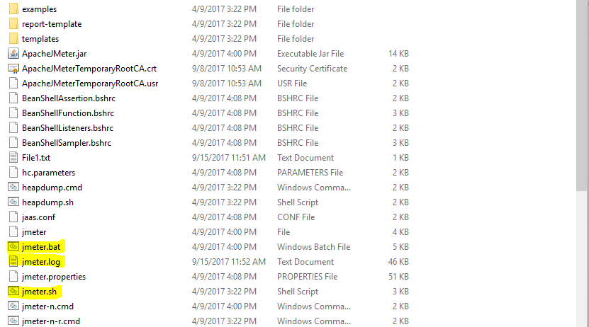

* 1. “*\apache-jmeter-3.2\lib\ext”*
     1. To use any external jar files in JMeter, place the jar files in the above directory and restart JMeter.
     2. Then the classes in the jar file can be used in Java Request or Beanshell Request.

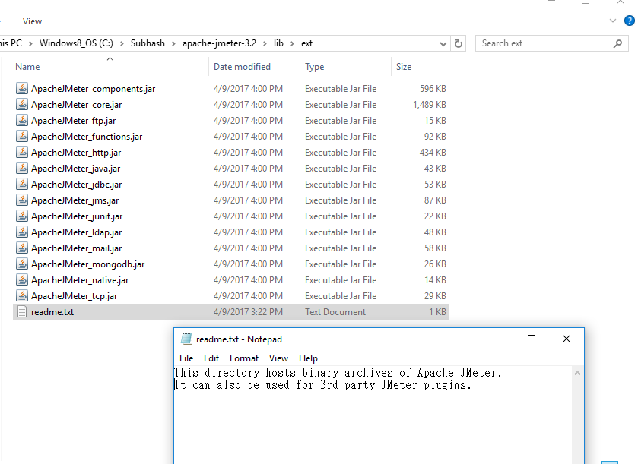

1. Run JMeter from Command Prompt
   1. JMeter GUI should be used mostly for creating test cases and maintenance activities only.
   2. During actual execution, we should run JMeter in command line mode as follows
   3. *jmeter -n -t [jmx file] -l [results file] -e -o [Path to output folder]*
2. Configure JMeter to run from TFS or from Builds.
   1. JMeter cannot be configured to run directly from TFS. MSVTS(Microsoft Visual Studio Team Services) supports JMeter. But it runs on cloud. So, this is not a viable option for CUB
3. Integrating JMeter into Maven
   1. Install Maven & Eclipse in your machine.
   2. Create a Maven Project in Eclipse (File->New->Other)

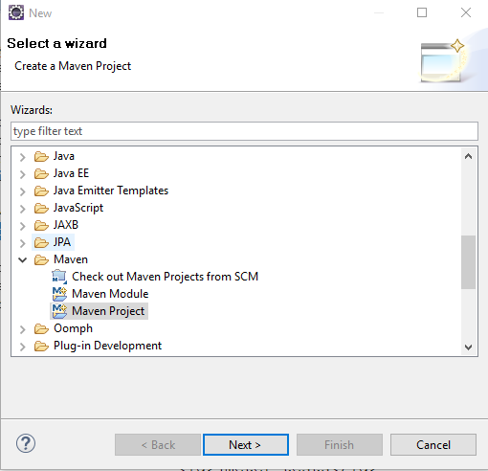

* 1. After creating the Maven Project, open the pom.xml in editor and add the following:

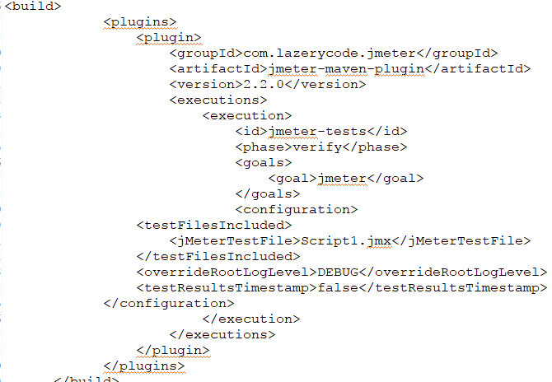

* 1. *“Script1.jmx”*  is the JMeter test script file
  2. To run the project “mvn install”. It will automatically trigger the test cases

1. Generating Reports in JMeter:
   1. JMeter supports dashboard report generation to get graphs and statistics from a test plan
   2. The dashboard generator is a modular extension of JMeter. Its default behavior is to read and process samples from CSV files to generate HTML files containing graph views.
   3. It can generate the report at end of a load test or on demand
   4. All the configurable parameters for Dashboad are available @<http://jmeter.apache.org/usermanual/generating-dashboard.html>
   5. Request the team to go through the link and build the reports.
2. Distributed load testing with JMeter

In the event that your JMeter client machine is unable, performance-wise, to simulate enough users to stress your server or is limited at network level, an option exists to control multiple, remote JMeter engines from a single JMeter client. By running JMeter remotely, you can replicate a test across many low-end computers and thus simulate a larger load on the server. One instance of the JMeter client can control any number of remote JMeter instances, and collect all the data from them. This offers the following features

* 1. Start the servers:

To run JMeter in remote node, start the JMeter server component on all machines you wish to run on by running the **JMETER_HOME/bin/jmeter-server** (unix) or **JMETER_HOME/bin/jmeter-server.bat** (windows) script.

Note that there can only be one JMeter server on each node

* 1. Add the server IP to your client's Properties File:

Edit the properties file *on the controlling JMeter machine*. In **JMETER_HOME/bin/jmeter.properties**, find the property named, "**remote_hosts**", and add the value of your running JMeter server's IP address. Multiple such servers can be added, comma-delimited.

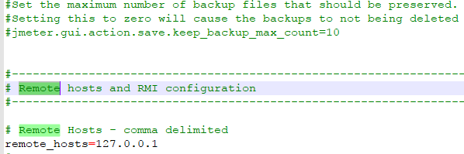

* 1. Start the JMeter Client from a GUI client to check configuration

Now you are ready to start the controlling JMeter client. For MS-Windows, start the client with the script "**bin/jmeter.bat**". For UNIX, use the script "**bin/jmeter**". You will notice that the Run menu contains two new sub-menus: "Remote Start" and "Remote Stop" (see figure 1). These menus contain the client that you set in the properties file. Use the remote start and stop instead of the normal JMeter start and stop menu items

